**Classroom Activity 3:** **Deploy your code through GitHub pages.**

**Steps:**

1. **Enable GitHub Pages and Configure Settings:**

* Go to your GitHub repository settings.
* Navigate to the "Pages" section.
* GitHub Pages might automatically detect your website files and offer a URL based on your repository name. You can leave it as is or choose a custom domain name (requires additional configuration).
* **Source:** Select "Deploy from a branch" and choose the branch containing your website files (usually main).
* Select the **main** branch
* **Visibility:** Set the desired visibility level (Public or Private).
* Click "Save" to activate GitHub Pages for your repository.

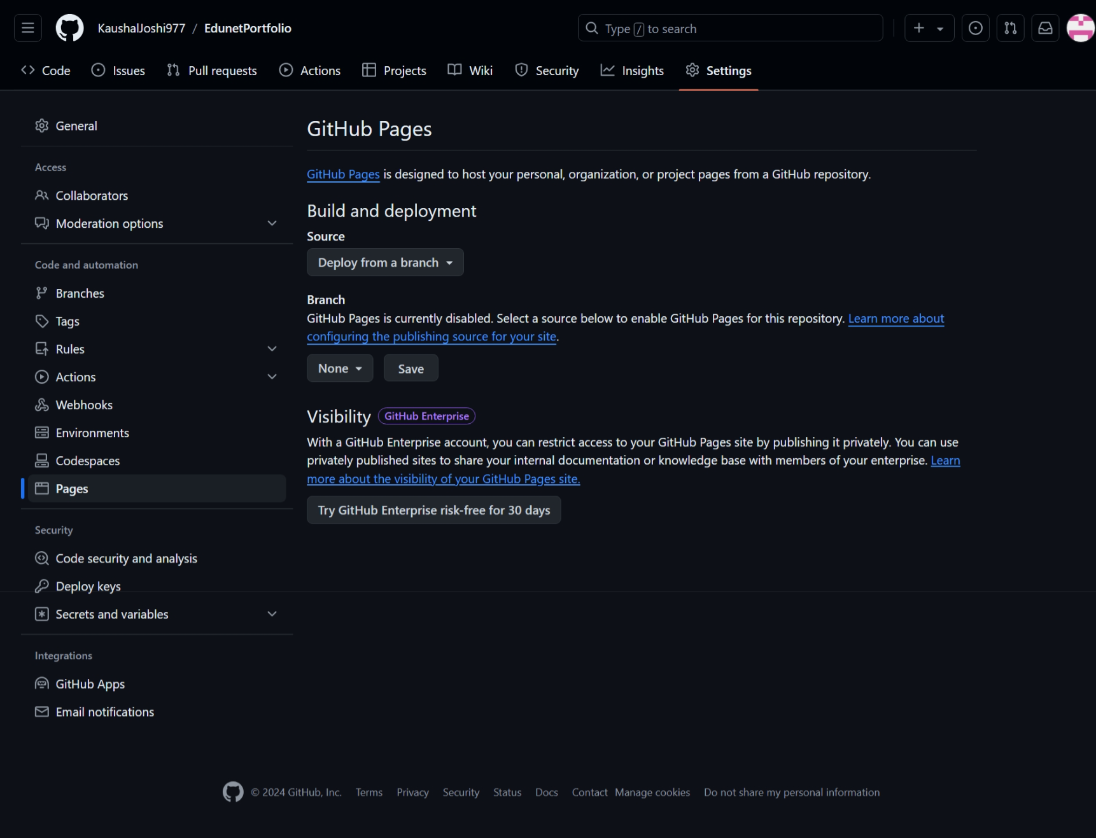

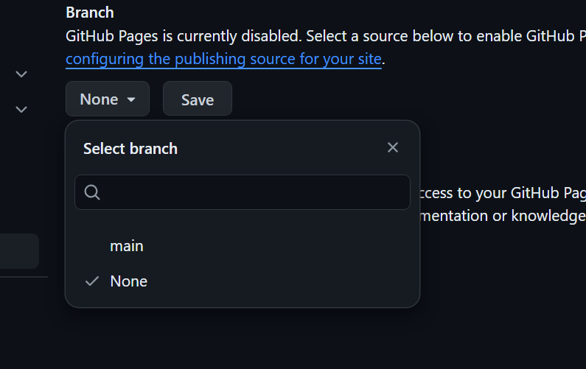

Select Main Branch

1. **Access Your Deployed Website:**

* After a short while (usually a few minutes), your website should be live!
* The URL for your deployed website will be displayed in the GitHub Pages section of your repository settings. It will likely follow the format https://username.github.io (replace username with your GitHub username).

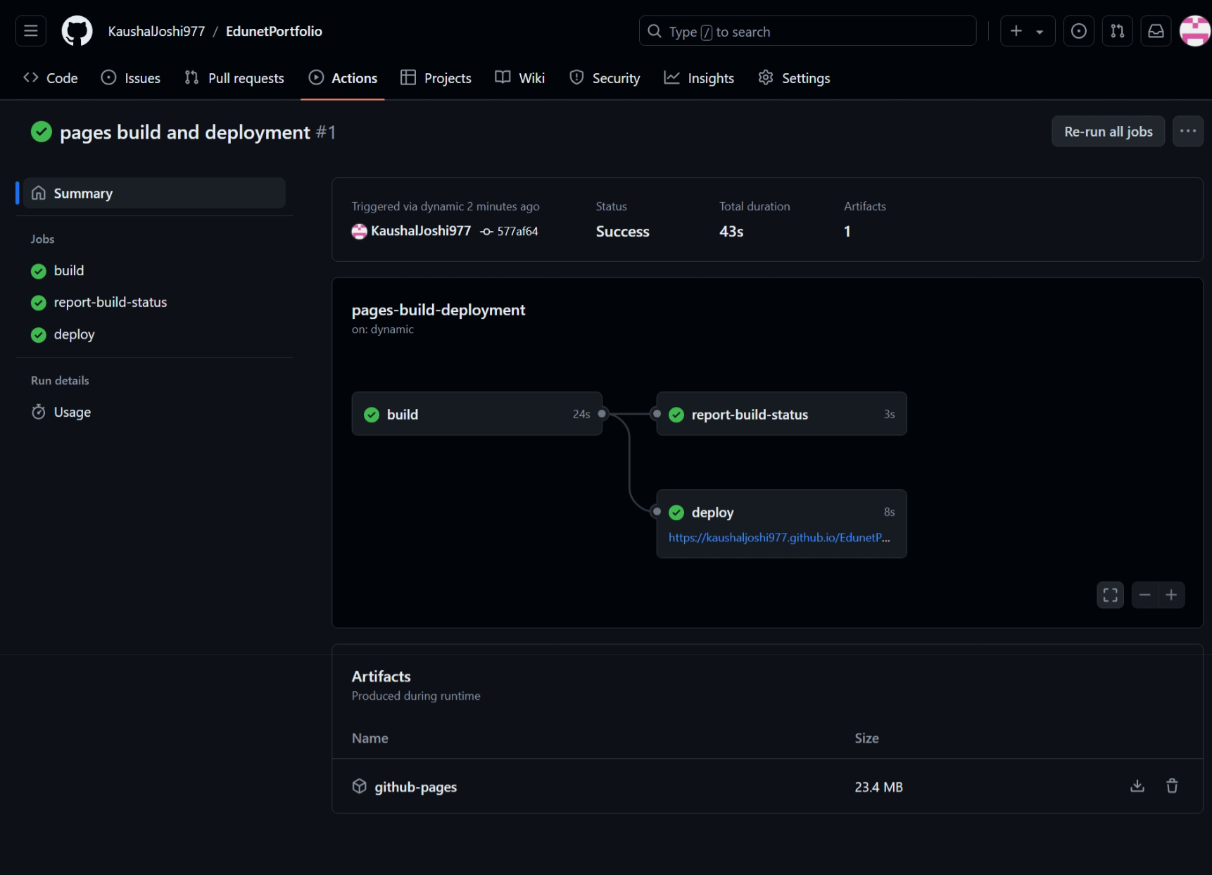

**Access Link:-** https://kaushaljoshi977.github.io/EdunetPortfolio/